# CS 255 Business Requirements Document Template

Complete this template by replacing the bracketed text with the relevant information.

This template lays out all the different sections that you need to complete for Project One. Each section has guiding questions to prompt your thinking. These questions are meant to guide your initial responses to each area. You are encouraged to go beyond these questions using what you have learned in your readings. You will need to continually reference the interview transcript as you work to make sure that you are addressing your client’s needs. There is no required length for the final document. Instead, the goal is to complete each section based on your client’s needs.

**Tip:** You should respond in a bulleted list for each section. This will make your thoughts easier to reference when you move into the design phase for Project Two. One starter bullet has been provided for you in each section, but you will need to add more.

## System Components and Design

### Purpose

*What is the purpose of this project? Who is the client and what do they want their system to be able to do?*

DriverPass would like to offer a learning service for student drivers to increase the rate at which students pass their final exams. DriverPass has discovered that nearly 65% fail and are creating a system to make a difference.

### System Background

*What does DriverPass want the system to do? What is the problem they want to fix? What are the different components needed for this system?*

The purpose of the project is to provide clients with training and simulations that will prepare them for their actual driver’s test. The targeted clientele for this project is student drivers. **Our** clientele is DriverPass, who would like the system to allow customers to schedule lessons based upon packages that can be purchased. Lessons are able to be cancelled or modified by the customer. The system will pair the customer with a driver and track all information and learning until the course is complete. The server side of the system will include security roles for different employees and data tracking that can be accessed online and offline

### Objectives and Goals

*What should this system be able to do when it is completed? What measurable tasks need to be included in the system design to achieve this?*

When the system is completed, users should be able to purchase packages based upon their needs, schedule driving appointments with an instructor, take practice exams and test, and review study materials. The system should also track the progress of the users and maintain measurables of the percentage of clients that pass their exams. This measurable will allow DriverPass to make changes or enhance their system if needed.

## Requirements

### Nonfunctional Requirements

*In this section, you will detail the different nonfunctional requirements for the DriverPass system. You will need to think about the different things that the system needs to function properly.*

#### Performance Requirements

*What environments (web-based, application, etc.) does this system need to run in? How fast should the system run? How often should the system be updated?*

* The system should be web-based
* The system should run over the cloud
* The system should update regularly with any policy changes by the DMV
* The system should be updated at any point DriverPass feels necessary. (Ex: to enhance the system)

#### Platform Constraints

*What platforms (Windows, Unix, etc.) should the system run on? Does the back end require any tools, such as a database, to support this application?*

* The system will run on the cloud to minimize security management

#### Accuracy and Precision

*How will you distinguish between different users?* *Is the input case-sensitive? When should the system inform the admin of a problem?*

* The system will consist of different roles. These roles will be assigned to different users.
* The system should consist of an option to “Report a bug”, this should be reviewed by administrators

#### Adaptability

*Can you make changes to the user (add/remove/modify) without changing code? How will the system adapt to platform updates? What type of access does the IT admin need?*

* IT will have access to perform maintenance on the system as well as make necessary modifications.

#### Security

*What is required for the user to log in? How can you secure the connection or the data exchange between the client and the server? What should happen to the account if there is a “brute force” hacking attempt? What happens if the user forgets their password?*

* If the user forgets their password, they should have the option to “Reset Password”
* In the event of a “brute force” hacking attempt, the account should be locked, and the user should be notified.
* Security data will be handled on the cloud

### Functional Requirements

*Using the information from the scenario, think about the different functions the system needs to provide. Each of your bullets should start with “The system shall . . .” For example, one functional requirement might be, “The system shall validate user credentials when logging in.”*

* The system shall allow user to login
* The system should validate users
* The system should provide password reset
* The system should allow users to make and modify appointments
* The system shall allow users to track progress
* The system should allow users to make purchases
* The system should allow users to take practice test
* The system should allow administrators to make updates and changes

### User Interface

*What are the needs of the interface? Who are the different users for this interface? What will each user need to be able to do through the interface? How will the user interact with the interface (mobile, browser, etc.)?*

* The users of the interface will include clients as well as administrators and other employees
* Customers should be able to browse the UI easily and navigate to the different features that the system is compiled of. (Purchasing lesson packages, viewing study materials, scheduling driving appointments, viewing/tracking progress, etc..)
* Administrators should be able to view UI and make any updates when necessary.
* The UI should be accessible via a browser.
* The UI should consist of all features that DriverPass wishes to incorporate. This should be easy to navigate.

### Assumptions

*What things were not specifically addressed in your design above? What assumptions are you making in your design about the users or the technology they have?*

* Users will be able to navigate the website
* Administrators will be knowledgeable on how to make changes and perform updates
* All users have internet access
* A driver will be available at any given time

### Limitations

*Any system you build will naturally have limitations. What limitations do you see in your system design? What limitations do you have as far as resources, time, budget, or technology?*

* DriverPass only has 10 cars available
* Possible outages could cause project delay or site delay
* The system may be incompatible with some older technology
* Any possible delays on the project may increase workload or time till completion.

### Gantt Chart

*Please include a screenshot of the GANTT chart that you created with Lucidchart. Be sure to check that it meets the plan described by the characters in the interview.*

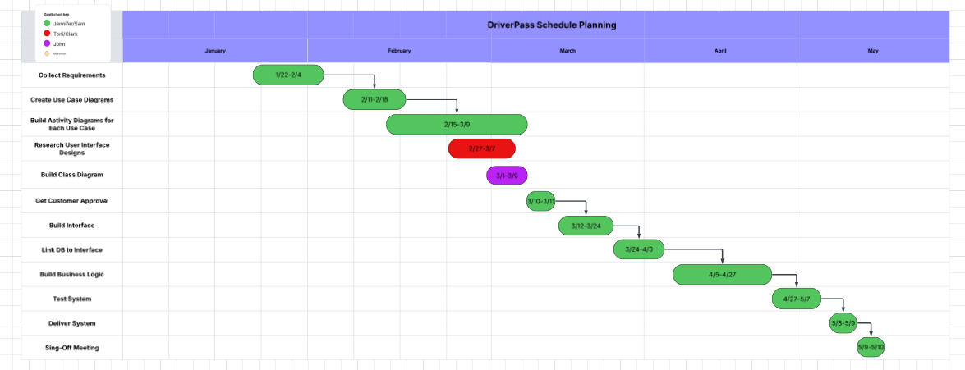

References:

DriverPass Interview Transcript, SNHU, 2025